**What is volleyball?**

Volleyball is a game where 6 players are on each side of a 7 foot 11 net, for Men's volleyball, or a seven foot four net for womens play. It is a sport you can play in every environment, inside or outside! The game of volleyball has evolved into many variations of the game. From the game’s inception in the indoor gym to variations such as four-man games to beach volleyball, even snow volleyball is a thing. There are many different ways to play volleyball and there are many different leagues to learn volleyball in.

Volleyball has played a major part in my life and it has taught me valuable lessons. For the seven years I have played this game I have never gotten bored of it. I would recommend everyone play it at least once in their life.

**Rules** (Page 2)

There are many rules to the game of Volleyball. I will be talking about the modern rules here. The main rule of volleyball is, DON'T LET THE BALL TOUCH THE GROUND. But besides that volleyball is an extremely intricate game once you get into it. The rules of volleyball are moderated, changed, and distributed by USAVolleyball.

**<h2> Setting up**

The net, the quintessential image of volleyball, is at a height of around seven feet, 11 ⅝ inches for men as stated in the introduction, then seven feet four inches for womens. The court boundaries consist of a large rectangle with the net in the middle. The court is fifty-nine feet by twenty-nine feet six inches with two lines on either side maring the ten foot lines; these will be important later.

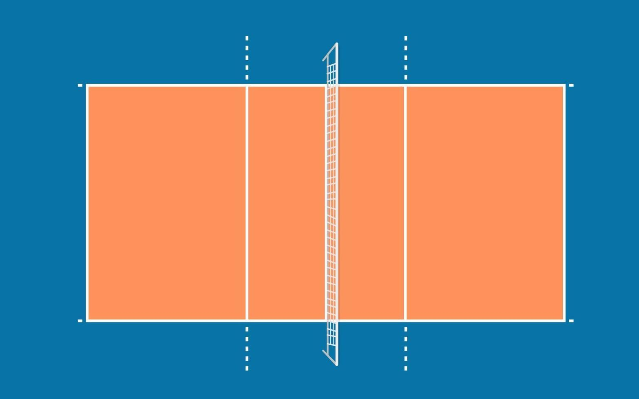

[Volleyball court image](https://www.vecteezy.com/vector-art/2634900-volleyball-court-top-view-vector-illustration)

Normal six v six volleyball games consist of three sets to 25. In the case of 24-24 it is a win by two scenarios. Meaning your team would have to score points making the score 26-24 to win.

**<h2> Basic rules**

To start the game, put six players on each side of the net. Have the player in the **back left hit/serve** the ball over the net from anywhere behind the back line. Do not cross the back line while serving or else the opposite team will automatically get the point (**Foot Fault**).

It doesn't matter where the ball is served to as long as it is in the other team's court.

If the ball hits the line in any way on the outside perimeter on the opposing team's court it is in play. Once the serve has been received, also known as the **serve receive**, the opposing team has 3 touches to send the ball back over the net. Then the **rally**, which is the name for the ball going back and forth over the net, will continue indefinitely until any team makes a mistake. This means, if the ball is touched more than three times on either side without it going over the net, it is the other team's point. Or it could be if the ball went out of bounds, or hit the ground in play. Players rotate **clockwise** around the court whenever possession is switched. **Possession** is switched when the team that is serving loses a point, prompting either team to rotate servers.

The image below shows how rotations look and the numbers are the different players on the court. Player 1 goes to Player 6, Player 6 goes to Player 5, Player 5 goes to Player 4 and so on.

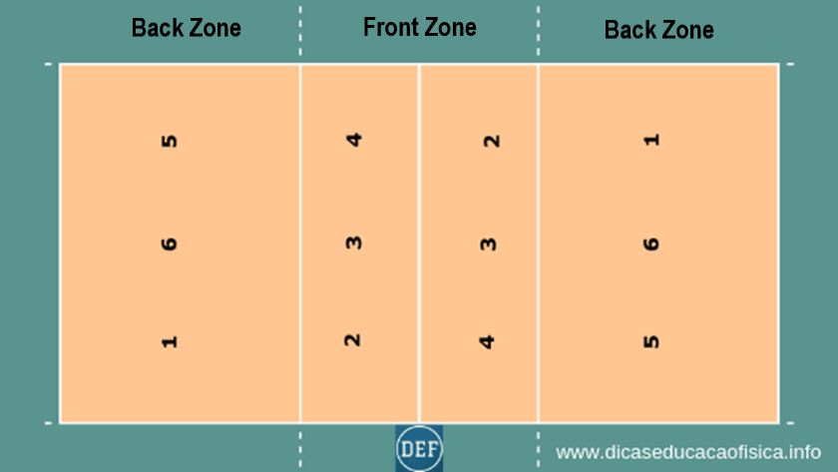

[Volleyball rotations](https://www.dicaseducacaofisica.info/wp-content/uploads/2019/07/volleyball-rotation.png)

<h1> **The History Of Volleyball**

Volleyball has a Long history dating back to 1895. Invented by William G. Morgan of the YMCA of Holyoke, Massachusetts. The original game for volleyball was "Mintonette" (FIVB) but then in 1896 the name was changed to “Volley Ball” then changed again in 1952 to a single word “Volleyball”.He even met the inventor of basketball, James Naismith in 1981. After that encounter he was inspired to make a game “less violent”(FIVB) and more suited to everyone. He wanted to make a game like no other “designed to be a combination of basketball, baseball, tennis and handball.”(OLYMPIC HISTORY), but this also caused some problems for him. Such as, how do you make a ball that can be hit, set, not hurt too much, and also be light enough to fly over the net?

Morgan had no comparisons to any other games he could use. He couldn't use a basketball skin because it was too heavy. He explained this starting with the net height, ”We raised it to a height of about 6 feet, 6 inches (1.98 meters) from the ground, just above the head of an average man. We needed a ball and among those we tried was a basketball bladder, but this was too light and too slow. We therefore tried the basketball itself, which was too big and too heavy."(FIVB) But he figured out a way to make these balls. The ball consisted of a leather exterior, with rubber inside to keep the ball aired up, with a “circumference was not less than 25 and not more than 27 inches” the ball was then manufactured by the A.G. Spalding & Bros firm. Back then the game was a lot different than it is today.

According to the FIVB Morgans game had an unlimited number of people being able to play the game at a time. In comparison to when in 1918 the number of players per team was only 6 people per side of the court. Some changes were made In the 1900s also, the ‘dribbling line’ was removed. According to NCVA(Northern California Volleyball association) it was a part of the original rules . Another rule change in 1900 was changing the original net height of 6’6 to 7’6 then to 7’11 for mens in the 1950s.

[William Morgan next to the ball he invented](https://inside.cev.eu/timeline/)

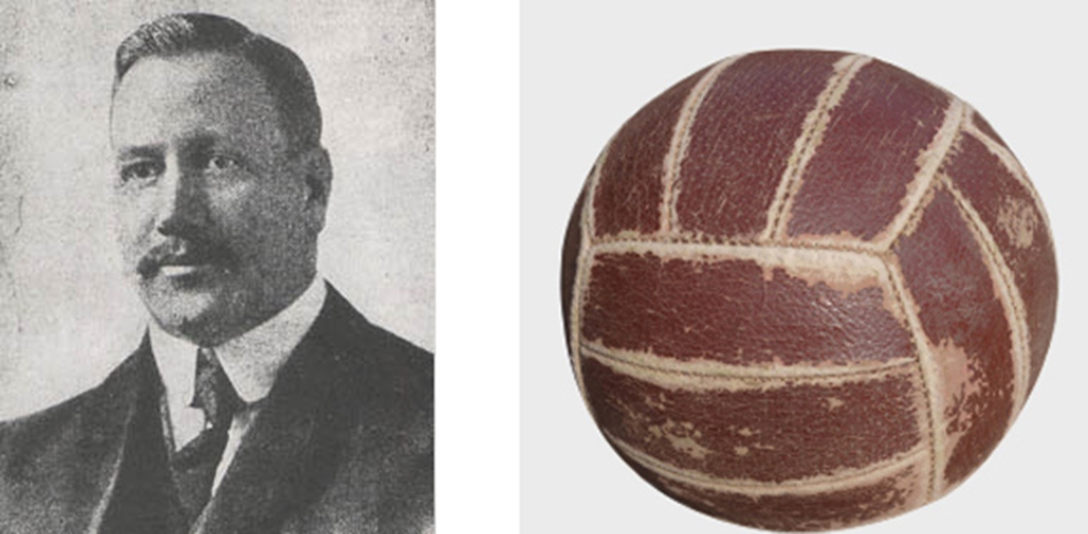

<h1> **Different positions and their roles**

There are six positions that you can play on a volleyball team. First of all you need to know what numbers correlate with the positions on the court. The numbers will be displayed as if the team is serving in their starting rotation. Meaning that the setteris the first to serve. I will also be splitting this page in two, the front row and the back row.

<h2>**Meet the Front row**

The **second** position is the outside hitter. The role of the front row outside hitter is to focus on hitting the ball from the setter. And block if the person on the other side of the net is hitting. The Outside hitter is the **Sword of the team** as the middle is the shield. To be an outside hitter you want to be good under pressure, be tall and/or be able to jump pretty high to get the highest you can over the net.

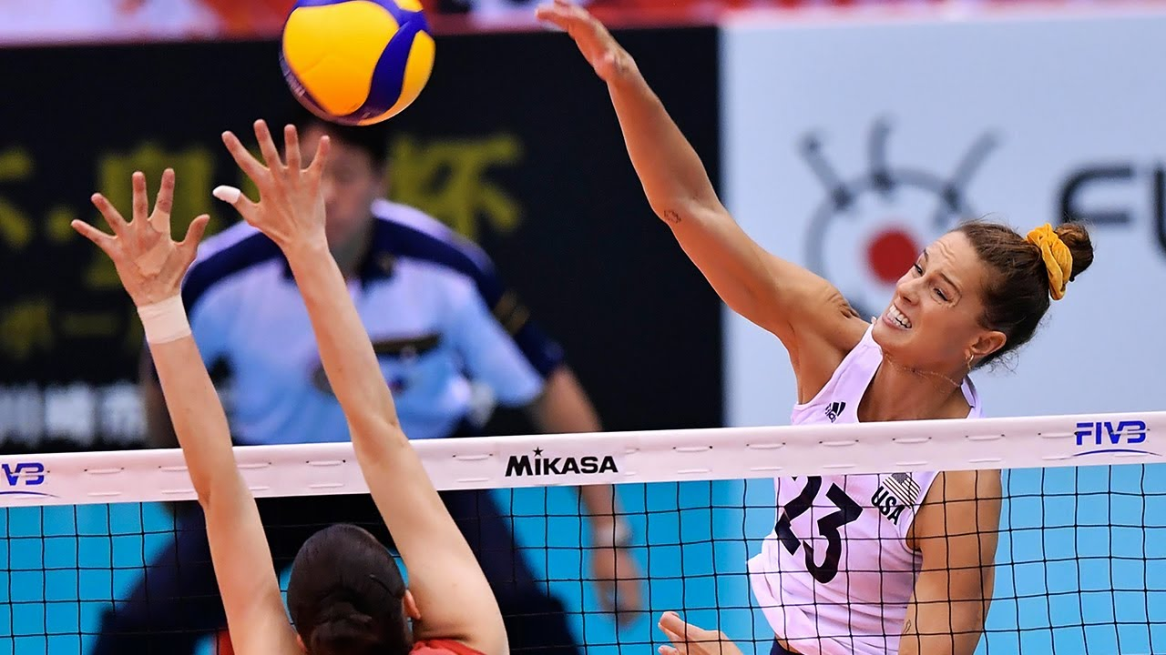[<outside hitter](https://i.ytimg.com/vi/H5l2BFLZR1E/maxresdefault.jpg)

The **Third** position is reserved for the middle blocker. The middle blockers role in his/her team is very simple. As a middle blocker myself I know all the ins and outs of this position. The job of the middle is to **be a wall** for any hitters hitting over the net. The best way to block is to put your hands straight up and then push over the net with your palms facing the ball like the Picture below.

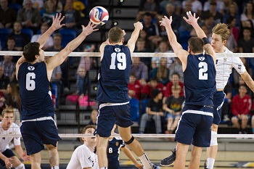[pic of middle blocker](https://www.strength-and-power-for-volleyball.com/images/volleyball-blocking-block.jpg)

In this picture you can see number nineteen, who is the middle blocker, has his hands over the net with his palms facing the hitter. He also has the outside and right side hitters helping him create a three man block.

The number **four** position is the rightside/weakside hitter. The job of the right side hitter is very similar to the job of the outside. Most of the time the right side hitter is a lefty due to the angles that a right handed hitter can hit. To hit the ball to the opposite side of the court as a right handed person you would have to hit over your shoulder. But as a lefty you have your entire body to swing, making the hit stronger and also more accurate.

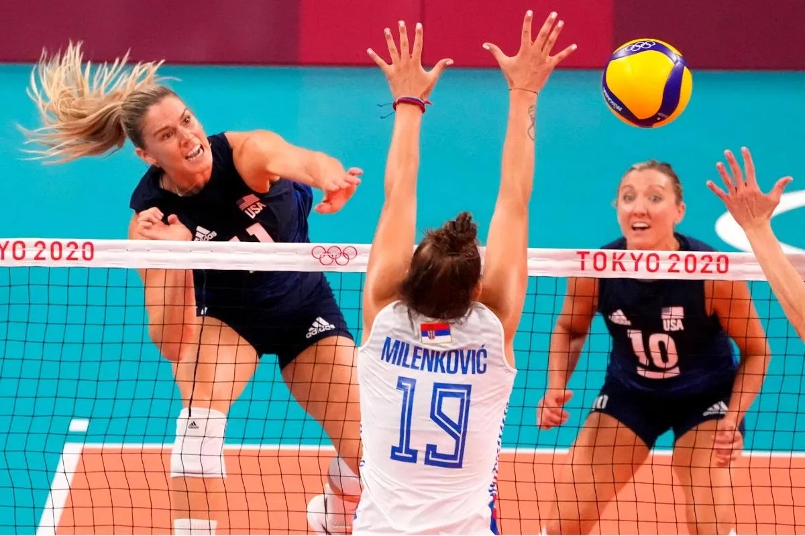[right side hitter pic](https://volleyballindex.com/wp-content/uploads/2022/01/Opposite-Hitter-Position-In-Volleyball.jpg)

<h2> **Meet the Back row**

The **one** position is normally reserved for the setter. The setter is, in essence, the air traffic controller of the game. Meaning he/she controls how the team plays the game by giving out hand signals, then setting up the hitters with sets which will be explained on the **Hand Signal page**(link to this page perhaps?) And also is responsible for keeping the team on track to win. Requirements to be a good setter would be that you have to be a great **leader,** know the hand signals and different plays that you and your team have created, and last but not least, you need to be able to work hard to get your sets in good places so your hitter can hit them.

In the **five** spots is the second outside. The second outside is just like the first outside. But the difference is that while the second outside is in the back they are responsible for helping the libero for covering the back row and to pass anything that gets through the blocks. As a backrow outside you have to be somewhat good at passing and also good at hitting the ball. Its an outside but staring in the back.

In the number **six** position is the second most important job on the team, besides the setter, would be the libero. The word **libero** is Italian for ‘free defender’,or literally ‘free beater’(Oxford Dictionaries). Which is honestly a great abbreviation for this position. The libero is the one that normally gets all the serves directed at him/her. Their job is to dig the ball into the air and to the center of the court to have the setter set. Making this position one of the more important ones.

<h1> **Strategies, Plays, and Hand Signals**

There are many different strategies, plays, ways of conveying those strategies to your teammates.

<h2> Hand signals

There are many different Hand signals used in volleyball. Hand signals are used to convey the plan between the setter and the hitters. You want to use hand signals so the other team does not know what you are about to do. There are 3 main rules when creating a hand signal to use. You need to be able to see the different hand signals, for example having one signal be a gun on your hand and the other having a three. The differences in the hand signals are important to practice with your teammates because not every hand signal means the same play will happen.

For starters a simple play would be for the middle, a simple 1 ball. The setter will always try to begin on the right of the center of the court on the net. The ball is set about a foot above the net to let the middle hit the ball quickly before it falls below the net and before the opponents can react. As shown in the picture below the one ball is meant to be hit quickly as it does not have any arc to it. The signal for this hit is to just put up a one.

The “normal” outside attack is a five ball. It is a lofty throw to give the outside attacker enough time to rotate from serving or defending to his hitting approach. This gives the outside that extra second to think where he/she is going to hit it, making it deadly, but also predictable.

This is where the more complex plays come into play. A setter showing a fist means a play called a “stack”. The middle attacker goes up for an attack but also has the outside player following behind, giving the attack more players in one spot. This in turn causes confusion and missed timing for the opponents to block. More complex plays are just like football plays where you don't want the opponent to know what way the ball is going and not give the opponent any time to react.

Another semi complex play is the shoot. A shot in all simplicity is an extremely fast set to the outside position. It is shown in the diagram as a light blue line. Although this play may seem simple at first, the timing between the setter and their outside needs to be on point. Through many hours of practice this is perfected.

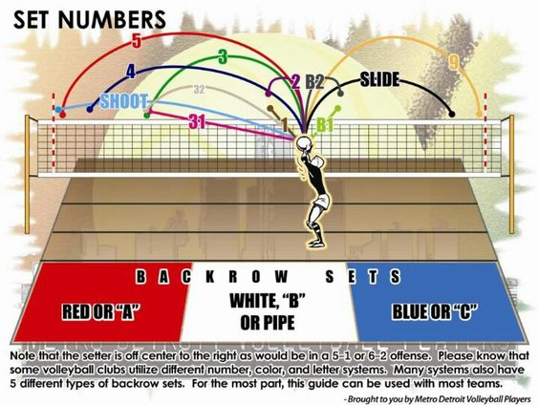

[volleyball plays](https://volleydojo.com/wp-content/uploads/set-numbers.jpg)

**<h2>Big names in volleyball today**

Volleyball has been expanding at exponential rates since a couple of decades ago. Helping the sport to expand. New organizations, clubs, even Olympic teams were made.

Some of the biggest names would include Taylor Averill, Patrick Gasman, Kerri Walsh Jennings, Paola Ogechi Egonu, and more. All of these players have cemented themselves as masters of their craft. Such as **Taylor Averill** who plays on the US olympic team. He is originally from Portland, Oregon, moved to his now hometown of San Jose, Calif. Also graduated from the University of Hawaii in 2015. He has been to many tournaments in his career, even going to the 2018 FIVB World Championship and landing in 3rd place, beating out many of his peers. Also Ranked number 2 in the nation in hitting percentage in 2015 at .488% which is outstanding and almost unbelievable.

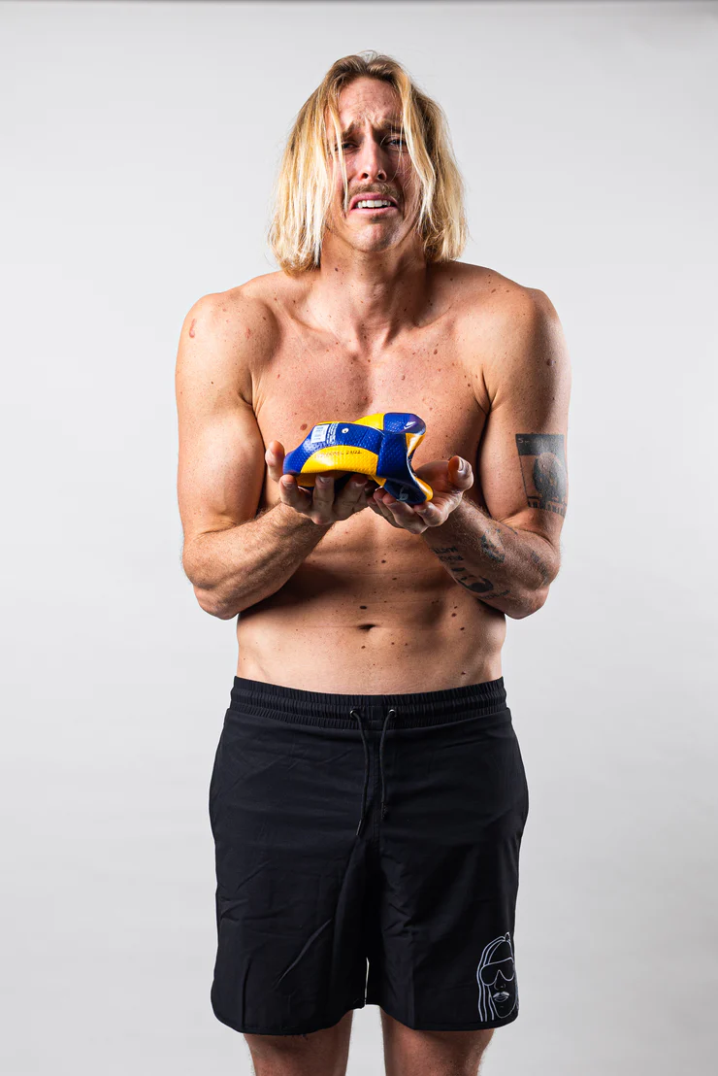[Taylor Averill](https://cdn.shopify.com/s/files/1/0508/9702/7241/products/IMG_1083_740x.jpg?v=1637687505)

**Paola Ogechi Egonu** is on the italy national women's team currently and as of yesterday the 16th of october, italy has shut out USA for bronze with Paola Ogechi Egonu leading the pack with 25 points and was named 2022 FIVB Nations League - "Most Valuable Player" (Wikipedia)She was born in Cittadella, in Veneto, to Nigerian parents. And even voiced in the Italian version of the movie Soul.

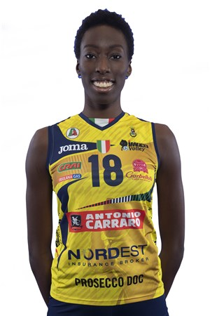[Paola Ogechi Egonu](https://www.fivb.org/Vis2009/Images/GetImage.asmx?Type=Press&No=89330&width=300&height=450&stretch=uniformtofill)

Lastly there is **Kerri Walsh Jennings**, a beach volleyball champion.Kerri Walsh Jennings is a 6′ 3″ monster on the beach scene. She took home the gold in the 2016 RIO olympics with her partner April Ross. She has also taken home 3 other gold metals and a bronze metal and is a five time olympian. She is also married to Casey Jennings, another beach player and has three children. She has many records that she still holds today, such as being the most decorated beach volleyball player and one of three that have 2 gold medals. On top of that she also Holds the record for tournament victories (domestic and international) with 135 and for career earnings with $2,648,135.00(TeamUSA). And also wants to partner with 2000 Olympic indoor volleyball teammate Logan Tom for a beach volleyball spot for the 2024 Paris Games.

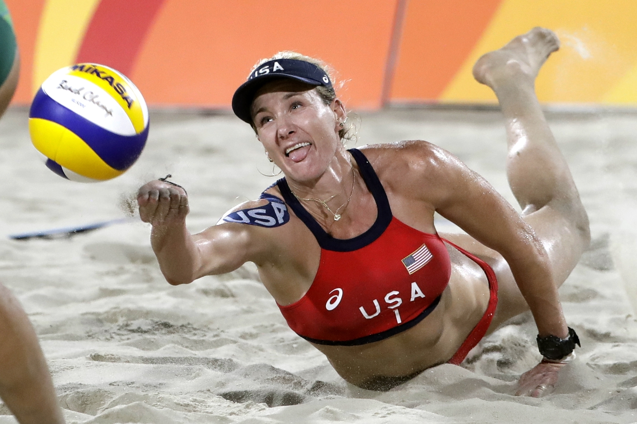[Kerri Walsh Jennings](https://arc-anglerfish-washpost-prod-washpost.s3.amazonaws.com/public/567MMREWVII6VB5DELJSII2WGY.jpg)

But there wouldn't be any big names without their teams. The main team in the news as of now 10/16/22 is the women's italy team with their shutout of the US for bronze. This came from the tournament “FIVB Volleyball Women's World Championship”, where italy and the US battled it out, but in the end italy won all three sets that were played.

**Resource page**

“10 Ways to Become a Better Setter.” *USA Volleyball*, 6 Jan. 2021, <https://usavolleyball.org/resource/10-ways-to-become-a-better-setter/.>

Oxford. “Oxford Languages and Google - English.” *Oxford Languages*, 18 Oct. 2022,

<https://languages.oup.com/google-dictionary-en/.>

“FVIB: The History of Volleyball.” *History - Volleyball*, 18 Oct. 2022,

<https://www.fivb.com/en/volleyball/thegame_glossary/history#:~:text=Volleyball%20has%20come%20a%20long,the%20sport%20back%20in%201895>.

“History of Volleyball.” *NCVA*, <https://ncva.com/info/general-info/history-of-volleyball/.>

Ioc. “Volleyball: A Brief History.” *International Olympic Committee*, IOC, 18 Oct. 2022, [https://olympics.com/ioc/news/volleyball-a-brief-history\.](https://olympics.com/ioc/news/volleyball-a-brief-history%5C.)

Oxford. “Oxford Languages and Google - English.” *Oxford Languages*,18 Oct. 2022, <https://languages.oup.com/google-dictionary-en/.>

“Rules of Volleyball.” *USA Volleyball*, 16 June 2021, <https://usavolleyball.org/play/rules-of-volleyball/.>

“Volleyball; The Game.” *History - Volleyball*, 18 Oct. 2022,

<https://www.fivb.com/en/volleyball/thegame_glossary/history#:~:text=Volleyball%20has%20com.>

“Kerri Walsh Jennings Statistics and Bio.” *Beach Volleyball Database*, 18 Oct. 2022

<http://bvbinfo.com/player.asp?ID=1923.>

“Kerri Walsh Jennings.” *Team USA*, 2022, 18 Oct. 2022

<https://www.teamusa.org/usa-volleyball/athletes/kerri-walsh.>

“Paola Egonu.” *Wikipedia*, Wikimedia Foundation, 17 Oct. 2022, <https://en.wikipedia.org/wiki/Paola_Egonu.>

“Taylor Averill.” *Team USA*, 2022, 18 Oct. 2022

<https://www.teamusa.org/usa-volleyball/athletes/taylor-averill.>